Provisioning Report
ASAP 7.0.2 – JAMU66
&
ASAP7.0.2 – WASS1133

Month: September

October 01st, 2018
Content

1. Summary Transaction Information from JAMU66 3
2. Summary Transaction Information from WASS1133 6
3. Tickets 9
4. Platforms refusing connectivity 12
5. RFC support 14

Summary Transaction Information from JAMU66

JAMU66
Transactions |  | 274,332 | 100%
Start Date |  | 01-August-2018 00:00:00 AM
End Date |  | 31-August-2018 23:59:59 PM
Order Status | Description | Values
COMPLETED | The order was completed with successful response from the Network Element | 244,135 | 89.27%
FAILED | The order was completed with error response from the Network Element | 26,412 | 8.86%
IN_PROG | Orders in Progress | 2 | 0.00%
TIMEOUT | Orders that exceeded the execution time | 3,783 | 1.87%
TRANSL_FAIL | Orders that were not executed | 0 | 0.00%

Day | Total | Transactions  Complete | %  Complete | Transactions  Failed | %  Failed | Transactions  In_Prog | %  In_Prog | Transactions  Timeout | %  Timeout | Transactions  Trans Fail | %  Trans Fail
01/09/2018 | 4,634 | 3,330 | 71.86% | 1,238 | 26.72% | 0 | 0.00% | 66 | 1.42% | 0 | 0.00%
02/09/2018 | 2,649 | 2,355 | 88.90% | 240 | 9.06% | 0 | 0.00% | 54 | 2.04% | 0 | 0.00%
03/09/2018 | 16,848 | 14,385 | 85.38% | 2,423 | 14.38% | 0 | 0.00% | 40 | 0.24% | 0 | 0.00%
04/09/2018 | 10,387 | 8,300 | 79.91% | 2,022 | 19.47% | 0 | 0.00% | 65 | 0.63% | 0 | 0.00%
05/09/2018 | 10,964 | 9,075 | 82.77% | 1,835 | 16.74% | 0 | 0.00% | 54 | 0.49% | 0 | 0.00%
06/09/2018 | 9,921 | 8,008 | 80.72% | 1,843 | 18.58% | 0 | 0.00% | 70 | 0.71% | 0 | 0.00%
07/09/2018 | 7,713 | 5,686 | 73.72% | 1,954 | 25.33% | 0 | 0.00% | 73 | 0.95% | 0 | 0.00%
08/09/2018 | 5,157 | 3,873 | 75.10% | 1,223 | 23.72% | 0 | 0.00% | 61 | 1.18% | 0 | 0.00%
09/09/2018 | 1,946 | 1,638 | 84.17% | 247 | 12.69% | 0 | 0.00% | 61 | 3.13% | 0 | 0.00%
10/09/2018 | 13,160 | 11,079 | 84.19% | 2,019 | 15.34% | 0 | 0.00% | 62 | 0.47% | 0 | 0.00%
11/09/2018 | 10,537 | 9,120 | 86.55% | 419 | 3.98% | 0 | 0.00% | 998 | 9.47% | 0 | 0.00%
12/09/2018 | 11,413 | 7,375 | 64.62% | 189 | 1.66% | 0 | 0.00% | 3,849 | 33.72% | 0 | 0.00%
13/09/2018 | 10,957 | 9,370 | 85.52% | 314 | 2.87% | 0 | 0.00% | 1,273 | 11.62% | 0 | 0.00%
14/09/2018 | 6,004 | 5,648 | 94.07% | 285 | 4.75% | 0 | 0.00% | 71 | 1.18% | 0 | 0.00%
15/09/2018 | 3,923 | 3,767 | 98.63% | 87 | 0.62% | 0 | 0.00% | 69 | 0.75% | 0 | 0.00%
16/09/2018 | 1,279 | 1,192 | 97.14% | 17 | 2.56% | 0 | 0.00% | 70 | 0.30% | 0 | 0.00%
17/09/2018 | 16,030 | 15,506 | 96.28% | 453 | 3.60% | 0 | 0.00% | 71 | 0.12% | 0 | 0.00%
18/09/2018 | 7,935 | 7,501 | 96.51% | 350 | 3.17% | 0 | 0.03% | 84 | 0.28% | 0 | 0.00%
19/09/2018 | 9,165 | 8,807 | 95.95% | 275 | 3.85% | 0 | 0.00% | 83 | 0.20% | 0 | 0.00%
20/09/2018 | 9,540 | 9,128 | 96.69% | 327 | 2.96% | 0 | 0.00% | 85 | 0.36% | 0 | 0.00%
21/09/2018 | 7,707 | 7,361 | 96.64% | 256 | 1.68% | 0 | 0.00% | 90 | 1.68% | 0 | 0.00%
22/09/2018 | 4,544 | 4,328 | 93.51% | 144 | 3.27% | 0 | 0.01% | 72 | 3.20% | 0 | 0.00%
23/09/2018 | 2,346 | 2,265 | 94.33% | 12 | 4.90% | 0 | 0.14% | 69 | 0.63% | 0 | 0.00%
24/09/2018 | 14,226 | 13,643 | 93.63% | 494 | 5.29% | 0 | 0.00% | 89 | 1.07% | 0 | 0.00%
25/09/2018 | 8,103 | 7,633 | 83.47% | 378 | 16.12% | 0 | 0.00% | 92 | 0.41% | 0 | 0.00%
26/09/2018 | 15,812 | 15,381 | 92.64% | 346 | 7.21% | 0 | 0.00% | 85 | 0.16% | 0 | 0.00%
27/09/2018 | 18,316 | 17,789 | 95.87% | 464 | 3.86% | 0 | 0.00% | 63 | 0.26% | 0 | 0.00%
28/09/2018 | 10,989 | 10,388 | 96.35% | 537 | 3.18% | 0 | 0.00% | 64 | 0.47% | 0 | 0.00%
29/09/2018 | 5,344 | 4,825 | 96.33% | 453 | 3.53% | 0 | 0.00% | 66 | 0.14% | 0 | 0.00%
30/09/2018 | 2,038 | 1,949 | 96.05% | 25 | 3.59% | 0 | 0.00% | 64 | 0.35% | 0 | 0.00%
SUMMARY  AVERAGE | 259,587 | 230,705 | 88.58% | 20,869 | 8.82% | 0 | 0.01% | 8,013 | 2.59% | 0 | 0.00%

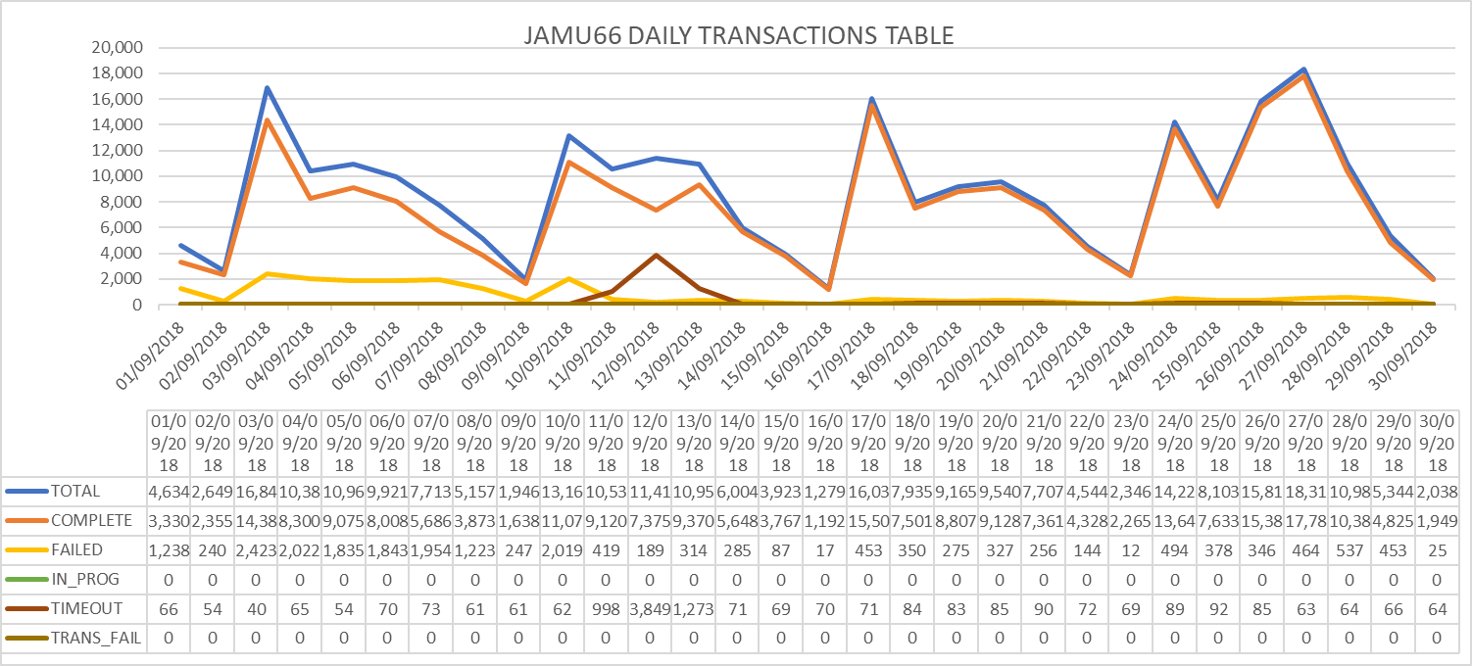

Summary Transaction Information from WASS1133

WASS1133 |  |  | %
Transactions |  | 97,290 | 100%
Start Date |  | 31-August-2018 00:00:00 AM
End Date |  | 31-August-2018 23:59:59 PM
Order Status | Description | Values
COMPLETED | The order was completed with successful response from the Network Element | 70,643 | 72.20%
FAILED | The order was completed with error response from the Network Element | 21,281 | 20.47%
IN_PROG | Orders in Progress | 1 | 0.00%
TIMEOUT | Orders that exceeded the execution time | 5,365 | 1.37%
TRANSL_FAIL | Orders that were not executed | 0 | 0.00%

Day | Total | Transactions  Complete | %  Complete | Transactions  Failed | %  Failed | Transactions  In_Prog | %  In_Prog | Transactions  Timeout | %  Timeout | Transactions  Trans Fail | %  Trans Fail
01/09/2018 | 1,764 | 1198 | 67.91% | 236 | 13.38% | 0 | 0.00% | 330 | 18.71% | 0 | 0.00%
02/09/2018 | 480 | 171 | 35.63% | 25 | 5.21% | 0 | 0.00% | 284 | 59.17% | 0 | 0.00%
03/09/2018 | 5,974 | 4997 | 83.65% | 802 | 13.42% | 0 | 0.00% | 175 | 2.93% | 0 | 0.00%
04/09/2018 | 4,156 | 3294 | 79.26% | 540 | 12.99% | 0 | 0.00% | 322 | 7.75% | 0 | 0.00%
05/09/2018 | 6,833 | 5739 | 83.99% | 850 | 12.44% | 0 | 0.00% | 244 | 3.57% | 0 | 0.00%
06/09/2018 | 3328 | 2604 | 78.25% | 401 | 12.05% | 0 | 0.00% | 323 | 9.71% | 0 | 0.00%
07/09/2018 | 2,695 | 1986 | 73.69% | 403 | 14.95% | 0 | 0.00% | 306 | 11.35% | 0 | 0.00%
08/09/2018 | 1,610 | 1163 | 72.24% | 205 | 12.73% | 0 | 0.00% | 242 | 15.03% | 0 | 0.00%
09/09/2018 | 358 | 99 | 27.65% | 17 | 4.75% | 0 | 0.00% | 242 | 67.60% | 0 | 0.00%
10/09/2018 | 5,974 | 4809 | 80.50% | 905 | 15.15% | 0 | 0.00% | 260 | 4.35% | 0 | 0.00%
11/09/2018 | 2,944 | 2178 | 73.98% | 433 | 14.71% | 0 | 0.00% | 333 | 11.31% | 0 | 0.00%
12/09/2018 | 3,126 | 2311 | 73.93% | 511 | 16.35% | 0 | 0.00% | 304 | 9.72% | 0 | 0.00%
13/09/2018 | 4,834 | 4045 | 83.68% | 448 | 9.27% | 0 | 0.00% | 341 | 7.05% | 0 | 0.00%
14/09/2018 | 2,637 | 2032 | 77.06% | 311 | 11.79% | 0 | 0.00% | 294 | 11.15% | 0 | 0.00%
15/09/2018 | 1,255 | 858 | 35.20% | 104 | 6.26% | 0 | 0.00% | 293 | 58.54% | 0 | 0.00%
16/09/2018 | 379 | 75 | 83.81% | 18 | 14.94% | 0 | 0.00% | 286 | 1.25% | 0 | 0.00%
17/09/2018 | 7,611 | 6299 | 88.64% | 981 | 10.53% | 0 | 0.00% | 331 | 0.83% | 0 | 0.00%
18/09/2018 | 3,628 | 2729 | 75.75% | 536 | 17.39% | 0 | 0.00% | 363 | 6.85% | 0 | 0.00%
19/09/2018 | 3,294 | 2537 | 87.27% | 393 | 11.42% | 0 | 0.00% | 364 | 1.31% | 0 | 0.00%
20/09/2018 | 4,928 | 3870 | 86.06% | 690 | 13.00% | 0 | 0.00% | 368 | 0.94% | 0 | 0.00%
21/09/2018 | 2,375 | 1634 | 55.89% | 338 | 14.01% | 0 | 0.00% | 403 | 30.10% | 0 | 0.00%
22/09/2018 | 1,240 | 779 | 80.51% | 138 | 11.46% | 0 | 0.00% | 323 | 8.03% | 0 | 0.00%
23/09/2018 | 557 | 239 | 87.10% | 16 | 9.72% | 0 | 0.00% | 302 | 3.19% | 0 | 0.00%
24/09/2018 | 5,646 | 4677 | 88.85% | 554 | 9.27% | 0 | 0.00% | 415 | 1.88% | 0 | 0.00%
25/09/2018 | 3,484 | 2634 | 80.58% | 461 | 12.39% | 0 | 0.00% | 389 | 7.02% | 0 | 0.00%
26/09/2018 | 3,639 | 2773 | 84.26% | 484 | 15.30% | 0 | 0.00% | 382 | 0.44% | 0 | 0.00%
27/09/2018 | 3,765 | 2914 | 83.05% | 564 | 16.28% | 0 | 0.00% | 287 | 0.68% | 0 | 0.00%
28/09/2018 | 2,426 | 2185 | 73.26% | 195 | 22.56% | 8 | 0.00% | 29 | 4.18% | 0 | 0.00%
29/09/2018 | 2,203 | 1419 | 81.94% | 540 | 17.26% | 0 | 0.00% | 244 | 0.80% | 0 | 0.00%
30/09/2018 | 451 | 190 | 86.06% | 22 | 13.17% | 0 | 0.00% | 239 | 0.77% | 0 | 0.00%
SUMMARY  AVERAGE | 93,594 | 72,438 | 74.99% | 12,121 | 12.81% | 8 | 0.00% | 9,018 | 12.21% | 0 | 0.00%

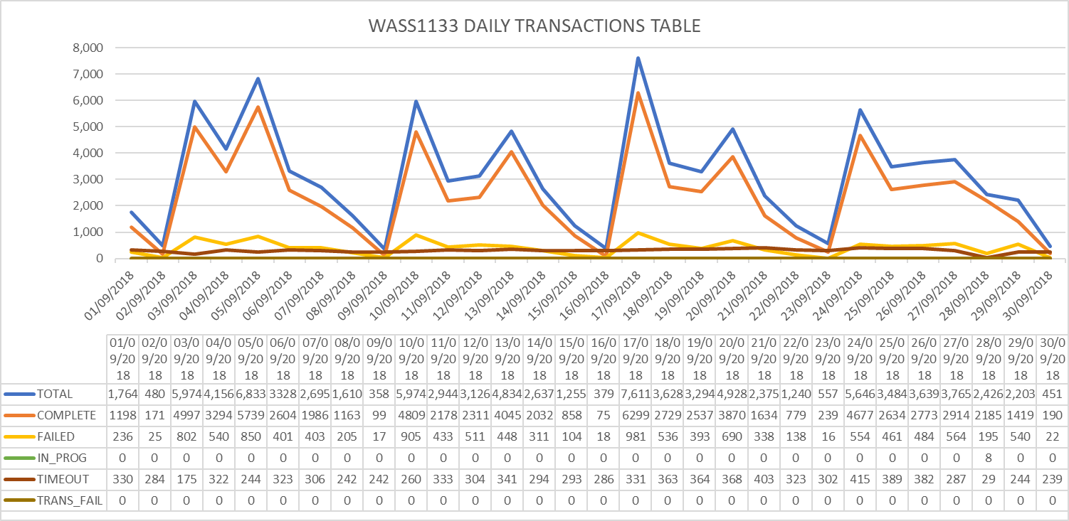

Tickets
June Statistics
Tickets | 28
Severity
LOW | 28
MEDIUM | 0
HIGH | 0
Origin
asap.support | 2
Case Mora | 1
Chinnasani | 2
JaganMohan | 1
Joy | 2
Kenyatta | 1
Kishore | 2
Madhusudan | 3
Neilsa | 2
Prakash | 5
Praneetha | 3
Samantha | 2
Suresh | 1
Terry | 1
Connection Refused | 0

Accumulative
Tickets | 310
Severity
LOW | 204
MEDIUM | 60
HIGH | 46
Origin
Abhijit | 1
asap.support | 16
Barbara | 2
Case Mora | 1
Chinnasani | 7
Chinnasani Prasanna | 1
FLOW IT AUTOMATED PROVISIONING | 1
Harish, Prakash | 2
IGATE LIBERATE TIER 2 SUPPORT | 1
JaganMohan | 1
Jason | 1
Joy | 18
Juan Pablo | 4
Kenyatta | 1
Kishore | 14
Kishore, Shalana | 1
León | 1
Madhusudan | 3
Madhusudhan Adapala | 4
Marcia | 1
Mark | 2
Mora | 1
Mounika | 12
Neilsa | 103
Neilsa, Chinnasani | 1
Neilsa, Kishore | 1
Nola | 2
Prackash | 19
Pradeep | 1
Praneetha | 16
Rhonda | 2
Rosaline | 1
Samantha | 7
Shalana | 3
Shivanchyut | 1
Shivanchyut Baghel | 1
Suresh | 8
Terry | 2
Uday | 2
Wendy | 1
Connection Refused | 43

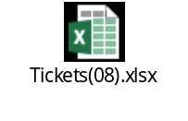

Platforms refusing connectivity

CONNECTION REFUSE E-MAIL TITLE | DATE | STATUS
ASAP monitor; connection refused SLU_UVF | 24/1/18 | CLOSED
ASAP monitor; connection refused EST_GSAT & EST_GSAT1 | 25/1/18 | OPEN
ASAP monitor; connection refused SLU_UVF | 30/1/18 | CLOSED
ASAP monitor; connection refused SLU_UVF | 2/2/18 | CLOSED
ASAP monitor; connection refused SLU_UVF | 5/2/18 | CLOSED
ASAP monitor; connection refused SLU_UVF | 6/2/18 | CLOSED
ASAP monitor; connection refused SLU_CEN | 5/2/18 | CLOSED
ASAP monitor; connection refused SLU_UVF | 9/2/18 | CLOSED
ASAP monitor; connection refused JAM_CALIX | 13/2/18 | OPEN
ASAP monitor; connection refused SLU_UVF | 16/2/18 | CLOSED
ASAP-WASS133-ASAP There is no connection to Database -No Listener | 18/2/18 | CLOSED
ASAP JAMU66 shutdown | 22/2/18 | CLOSED
ASAP monitor; connection refused SLU_UVF | 22/2/18 | CLOSED
ASAP monitor; connection refused CAY_GNBND with WASS1133 | 22/2/18 | OPEN
ASAP monitor; connection refused SLU_UVF | 22/2/18 | CLOSED
ASAP monitor; connection refused SLU_UVF | 28/2/18 | CLOSED
WASS1133-ASAP provisioning asappro1 user fails to login | 28/2/18 | CLOSED
ASAP monitor; connection refused SLU_CEN | 5/3/18 | CLOSED
JAM_MOBY connection failure | 9/3/18 | CLOSED
ASAP-FLOW-monitor, Unable to connect to remote host: Connection refused to SLU_UVF | 13/3/18 | CLOSED
ASAP monitor; connection refused SLU_UVF | 14/3/18 | CLOSED
ASAP monitor; connection refused SLU_UVF | 28/3/18 | CLOSED
ASAP monitor; connection refused SLU_UVF | 2/4/18 | CLOSED
ASAP monitor; connection refused SLU_UVF | 3/4/18 | CLOSED
ASAP monitor; connection refused JAM_EAST | 3/4/18 | CLOSED
ASAP monitor; connection refused SLU_UVF | 5/4/18 | CLOSED
ASAP monitor; connection refused SLU_UVF | 9/4/18 | CLOSED
ASAP connection refused SONUS | 11/4/18 | CLOSED
ASAP connection refused SONUS | 16/4/18 | CLOSED
ASAP monitor; connection refused SLU_UVF | 16/4/18 | CLOSED
ASAP monitor; connection refused SLU_UVF | 26/4/18 | CLOSED
ASAP monitor; connection refused SLU_CEN | 26/4/18 | CLOSED
ASAP monitor; connection refused SLU_UVF | 30/4/18 | OPEN
ASAP monitor; connection refused SLU_UVF | 2/5/18 | CLOSED
LIME-ASAP-jamu66-Connection Fail to SONUS platform | 28/5/18 | CLOSED
ASAP monitor; connection refused SLU_UVF | 11/06/18 | CLOSED
ASAP monitor; connection refused SLU_UVF | 11/06/18 | CLOSED
ASAP monitor; connection refused SLU_UVF and SLU_CEN | 19/06/18 | CLOSED
ASAP monitor; connection refused SLU_UVF and SLU_CEN | 21/06/18 | CLOSED
ASAP-Route Activation traffic to wass1133 | 24/06/18 | CLOSED
ASAP monitor; connection refused SLU_UVF | 03/07/18 | CLOSED
ASAP monitor; connection refused SLU_UVF | 04/07/18 | CLOSED
ASAP monitor; connection refused SLU_UVF | 23/07/18 | CLOSED

RFC support

CONCEPT | DATE
RFC 4080434 - Barbados HLR CP Upgrade from R12B to R15A | 25/01/2018
|RFC6786| SCHEDULED RFC NOTIFICATION Cleandata Routine Maintenance on JAMU66 | 22/02/2018
RFC6955-Reroute provisioning on Barbados HLR to Jamaica HLR - MW3 | 7/03/2018
|RFC7430| SCHEDULED RFC NOTIFICATION Routine Maintenance: ASAP Cleandata on JAMU66 server | 11/04/2018
|RFC8041| SCHEDULED RFC NOTIFICATION ASAP Cleandata Maintenance Activity - JAMU66 | 24/05/2018

